AI-DRIVEN MALICIOUS USER PREVENTION & DETECTION IN SOCIAL MEDIA
ABSTRACT
The proposed web application “Malicious User Detection and Prevention in Social Network” will be developed using Python Django Framework and MySQL database. Everyone today actively uses online social networks to get in touch with their friends, for career opportunities, and business also. Some of the most popular social networks are Facebook, Instagram, LinkedIn, and Twitter. But the question is how much their authentication systems are built in a secured way. The authentication systems mostly depend on the user's general details such as name, photo, and location. In such systems, mischievous persons can easily create fake profiles by cloning the user’s identity to abuse the user’s information. Using fake profiles they can misuse original user’s photos, contacts, and videos. This kind of mischievous person can be identified by the use of privacy detection mechanisms. So, this research emphasizes some data mining techniques for protecting the original user’s information and to identify the malicious accounts in social network sites. By the assessment of 3PS (Publically Privacy Protection System), this work employs the malicious account detection method in OSN depending upon the mischievous person’s uncountable shared posts in a day and latest activity and behaviours. Examining the network similarity and comparison of attributes threshold values referred to the original user’s profile can be used to identify the malicious accounts. For this E_SVM-NN classifier is used based on the feature reduction techniques. This work involves in creating OSN accounts for experiments and investigates the latest updates, posts, comments, photos, and performing online search etc. which are used to evaluate the effectiveness and significance of the proposed work in contrast to the previous works.

1. INTRODUCTION

1.1ABOUT THE PROJECT
In recent years, the exponential growth of social networks has transformed the way individuals connect, communicate, and share information. While these platforms have provided unprecedented opportunities for social interaction, they have also become breeding grounds for malicious activities. Malicious users, including cybercriminals, trolls, and spammers, exploit the open nature of social networks to disseminate harmful content, deceive users, and compromise the integrity of online communities. Detecting and preventing the activities of malicious users has thus become a critical challenge for maintaining the security and trustworthiness of social networks.
The consequences of malicious user activities on social networks are far-reaching. From the spread of misinformation and fake news to cyberbullying and identity theft, these activities not only jeopardize the safety and well-being of users but also erode the credibility of the platforms themselves. To address these issues, researchers and cyber security experts have been developing sophisticated techniques and tools for the detection and prevention of malicious user behaviour within social networks.
Malicious user detection involves the identification of abnormal or harmful activities that deviate from normal user behaviour. This encompasses a wide range of behaviours, including the creation of fake accounts, posting malicious content, engaging in coordinated attacks, and manipulating user sentiments. Prevention strategies aim to proactively stop or mitigate the impact of malicious activities before they cause harm, often relying on a combination of machine learning algorithms, data analytics, and user behaviour modelling.
It delves into the various types of malicious activities that commonly occur on these platforms, the challenges associated with detecting them, and the innovative approaches being employed to safeguard users and the integrity of social networks. As social networks continue to play a central role in shaping online interactions, understanding and addressing the threats posed by malicious users are essential for fostering a secure and trustworthy digital environment.

1.2. SYSTEM SPECIFICATION
1.2.1 HARDWARE REQUIREMENTS
System : Intel Core i5 due processor 2.5 GHz Speed
Hard Disk : 500 GB
Monitor : Dell UltraSharp U2419H
Mouse : Optical mouse
Keyboard : Standard Keyboard
RAM : 8 GB

1.2.1 SOFTWARE REQUIREMENTS
Operating System : Windows 11
Language : PYTHON DJANGO FRAMEWORK
Back end : MYSQL

1.3 SOFTWARE DESCRIPTION
1.3.1INTRODUCTION TO FRONT END
PYTHON:
Python is a high-level, interpreted and general-purpose dynamic programming language that focuses on code readability. The syntax in Python helps the programmers to do coding in fewer steps as compared to Java or C. Python is widely used in bigger organizations because of its multiple programming paradigms. They usually involve imperative and object-oriented functional programming. It has a comprehensive and large standard library that has automatic memory management and dynamic features.
The software development companies prefer Python language because of its versatile features and fewer programming codes. Nearly 14% of the programmers use it on the operating systems like UNIX, Linux, Windows and Mac OS. Interactive
Advantages or Benefits of Python
The Python language has diversified application in the software development companies such as in gaming, web frameworks and applications, language development, prototyping, graphic design applications, etc. This provides the language a higher plethora over other programming languages used in the industry. Some of its advantages are-
Extensive Support Libraries
It provides large standard libraries that include the areas like string operations, Internet, web service tools, operating system interfaces and protocols. Most of the highly used programming tasks are already scripted into it that limits the length of the codes to be written in Python.

Presence of Third Party Modules:
The Python Package Index (PyPI) contains numerous third-party modules that make Python capable of interacting with most of the other languages and platforms.
- Integration Feature
Python integrates the Enterprise Application Integration that makes it easy to develop Web services by invoking COM or COBRA components. It has powerful control capabilities as it calls directly through C, C++ or Java via Jython. Python also processes XML and other markup languages as it can run on all modern operating systems through same byte code.
- Improved Programmer’s Productivity
The language has extensive support libraries and clean object-oriented designs that increase two to ten fold of programmer’s productivity while using the languages like Java, VB, Perl, C, C++ and C#.
- Productivity
With its strong process integration features, unit testing framework and enhanced control capabilities contribute towards the increased speed for most applications and productivity of applications. It is a great option for building scalable multi-protocol network applications.
- Open Source and Community Development:
Python language is developed under an OSI-approved open source license, which makes it free to use and distribute, including for commercial purposes.
Further, its development is driven by the community which collaborates for its code through hosting conferences and mailing lists, and provides for its numerous modules.
- Learning Ease and Support Available:
Python offers excellent readability and uncluttered simple-to-learn syntax which helps beginners to utilize this programming language. The code style guidelines, PEP 8, provide a set of rules to facilitate the formatting of code. Additionally, the wide base of users and active developers has resulted in a rich internet resource bank to encourage development and the continued adoption of the language.
- User-friendly Data Structures:
Python has built-in list and dictionary data structures which can be used to construct fast runtime data structures. Further, Python also provides the option of dynamic high-level data typing which reduces the length of support code that is needed.

Simple and easy to Learn
- The syntaxes of python language are very simple. Anybody can remember the python language syntaxes, rules and regulations very easily.
- The elegant syntaxes of the python language makes the people to learn python in easiest manner.
- With out having any other programming languages knowledge, we can learn python directly.
- The simple and powerful syntax of python language makes the programmers to express their business logic is less lines of code.

Platform Independent :
- Like Java programs, Python programs are also platform independent.
- Once we write a Python program, it can run on any platform without rewriting once again.
- Python uses PVM to convert python code to machine understandable code.

High Level Language :
- Python is a high level language.
- While developing python applications, developers no need to bother about memory management.

Dynamically Typed Language :
- Python is a dynamically typed language. I mean, in python there is no need to declare type of a variable.
- Whenever we assign a value to the variable, based on the value the type will be allocated automatically.

Python supports POP &OOP :
- Python language supports both Procedural Oriented Programming and Object Oriented Programming features.
- We can implement OOPs features like Encapsulation, polymorphic, inheritance and abstraction in python programming language.

Python is interpreted Language :
- Like PHP, Python is also interpreted language.
- Python applications do not require explicit compilation so that compiler is not require for python software.
- Python interpreter is responsible for execution of python applications.
- When ever we run a python application, the python interpreter checks for the syntax errors. If there is no syntax errors found in our code then the interpreter converts the code into intermediate code in the form of low level format and executes it.
- The intermediate code of the python applications is known as byte code.
- The extension of the byte code file is .pye (Python Compile Code).

Python is Embeddable :
- We can embed the python code into other languages such as C,C++, Java and Etc..
- In order to provide the scripting capabilities to other languages we can use the python code in it.

Develop GUI & Web Application :
- We can develop the GUI based applications using Python Languages.
- We can also develop the Web applications using Python Language.

Applications of Python:
- GUI based desktop applications
- Image processing and graphic design applications
- Scientific and computational applications
- Games
- Web frameworks and web applications
- Enterprise and business applications
- Operating systems
- Language development
- Prototyping
FLASK:
The Flask framework is actually a glue, a very nice one, that sticks together the amazing Werkzeug and Jinja2 frameworks, responsible for answering requests and presenting the output (HTML, maybe). In the MVC architecture, also known as Model-View-Controller, Flask covers C and V. But where is M? Flask does not provide you with an integrated model layer out-of-the-box as that is not actually needed for a web application. If you do need to work with a database, just pick your database solution from the many available and create your own model layer, which is not hard, and be happy! The concept of a micro-framework, with good intentions and made just for Flask, is all about giving you the the smallest (but also the most useful) feature set you need, and one that won't get in the way.
Just what are the features that must be in the framework
- A development server and debugger
- Unicode support
- WSGI compliance
- A unit-test client
- URL routing
- Request dispatching
- Secure cookies
- Sessions
- Jinja2 templates

Why is Flask a good web framework choice?
Flask is considered more Pythonic than the Django web framework because in common situations the equivalent Flask web application is more explicit. Flask is also easy to get started with as a beginner because there is little boilerplate code for getting a simple app up and running.
How does Flask relate to the Pallets Projects?
Flask was originally designed and developed by Armin Ronacher as an April Fool's Day joke in 2010. Despite the origin as a joke, the Flask framework became wildly popular as an alternative to Django projects with their monolithic structure and dependencies.
Flask's success created a lot of additional work in issue tickets and pull requests. Armin eventually created The Pallets Projects collection of open source code libraries after he had been managing Flask under his own GitHub account for several years. The Pallets Project now serves as the community-driven organization that handles Flask and other related Python libraries such as Lektor, Jinja and several others.

1.3.2 INTRODUCTION TO BACK END
MY-SQL 4.0
MySQL is a full-featured relational database management system. It is very stable and has proven itself over time. MySQL has been in production for over 10 years. MySQL is a multithreaded server. Multithreaded means that every time someone establishes a connection with the server, the server program creates a thread or process to handle that client's requests. This makes for an extremely fast server. In effect, every client who connects to a MySQL server gets his or her own thread.

Yet another feature of MySQL is its portability—it has been ported to almost every platform. This means that you don't have to change your main platform to take advantage of MySQL. And if you do want to switch, there is probably a MySQL port for your new platform.

MySQL also has many different application programming interfaces (APIs). They include APIs for Perl, TCL, Python, C/C++, Java (JDBC), and ODBC. So no matter what your company's expertise is, MySQL has a way for you to access it.

MySQL is also very cheap. For an unlicensed, full version of MySQL, the cost is nothing. To license your copy will currently cost you $200. This is an incredible deal, considering what you are getting for your money. Database systems that provide half the features that MySQL has can cost tens of thousands of dollars. MySQL can do what they do better and for less.

MySQL is a relational database. It uses tables and columns to hold data that can be related by keys. It is well suited for this role. It is also very well suited for various architectures. It can be used in a strictly client/server architecture or as a standalone database.

The MySQL Supported Types

MySQL has various data types that support different functions. A data type is the type of data a column will store. There can be many different data types inside a table, but each column will store its own specific type of information. You can think of a data type as a kind of definition for a column.

A column defined as an integer column will only hold numeric information, whereas a column defined as a CHAR(10) will hold up to 10 alphanumeric characters. These definitions are the key to a quick and efficient database. There are basically three groups of data formats. The first is obviously numeric. Numeric data is data that is a positive or negative number such as 4 or -50.

Numeric data can also be in hexadecimal format (2ee250cc), scientific notation (2X10^23), or a decimal. The second type is character or string format. This format can consist of letters and numbers, whole words, addresses, phone numbers, and generally anything you have to put quotations around.

It consists of everything that doesn't quite fit into either of the other two categories. Some, like dates and times, could be alphanumeric but are stored like numbers.As well as data types, MySQL also provides column modifiers. These modifiers further help define a column's attributes.

They are AUTO_INCREMENT, UNSIGNED, PRIMARY KEY, NULL, NOT NULL, and BINARY. A more detailed discussion of column modifiers takes place following the coverage of the
basic data types.

MySQL runs on many platforms, and binaries are available for most of them. Binaries are the result of compiling the source code. This is by far the easiest way of acquiring MySQL. The alternative is downloading the source code for your platform and then compiling it.
MySQL has many utilities to import as well as export data.It shares some of the common options, but this utility does a little more. It takes the entire database and dumps it into a single text file.

This file contains all the SQL commands needed to recreate your database. It takes the schema and converts it to the proper DDL syntax (CREATE statements), and it takes all the data and creates INSERT statements out of them. This utility reverse engineers your database.
2.SYSTEM STUDY
2.1. EXISTING SYSTEM
Now a days we are using Hootsuite, it is primarily known as a social media management platform that allows users to schedule and manage content across various social media channels. Hootsuite allows organizations to manage access and permissions for team members. This can help in controlling who has access to social media accounts and ensuring that only authorized individuals can publish content or access sensitive information. Hootsuite facilitates the scheduling and posting of social media content, allowing organizations to plan and review posts before they go live. This can contribute to content accuracy and compliance with brand guidelines.

2.1.1DRAWBACKS OF EXISTING SYSTEM

- Hootsuite's subscription-based pricing can be prohibitive for small businesses or individual users.
- Users may experience challenges in adapting to Hootsuite's interface and mastering its features.
- Changes or disruptions to social media platform APIs can affect Hootsuite'sfunctionality.
- Hootsuite's real-time engagement features may not match the immediacy of native social media platforms.
- The depth of analytics provided by Hootsuite might be insufficient for users with advanced reporting needs.
- Top of Form

2.2. PROPOSED SYSTEM
The proposed systemaims to fortify the security infrastructure of online platforms, safeguarding users from various threats such as fake accounts, cyberbullying, and phishing attempts. Leveraging advanced technologies like machine learning, natural language processing, and social network analysis, the system establishes baseline user profiles, enabling the identification of anomalous behaviours indicative of malicious intent. Real-time monitoring ensures prompt detection of suspicious activities, while behavioural biometrics and geo
Location analysis add layers of verification to enhance user authentication. The project prioritizes user education through alerts and notifications, empowering individuals to recognize and report potential threats. By implementing adaptive security policies and collaborating with security agencies, the system continuously evolves to counter emerging cyber threats. Emphasizing privacy protection and compliance with data regulations, the project seeks to create a safer and more resilient online environment.
2.2.1FEATURES OF PROPOSED SYSTEM
- The system employs advanced technologies to proactively detect and prevent malicious activities, ensuring a heightened level of security for social media users.
- With continuous real-time monitoring, the system quickly identifies suspicious activities, allowing for swift responses to potential threats on social media platforms.
- Through user education, alerts, and notifications, the system empowers individuals to recognize and report malicious behaviour, fostering a collaborative approach to online security.
- The implementation of adaptive security policies ensures that the system evolves to counter emerging cyber threats, maintaining a proactive stance against evolving malicious tactics.
- Emphasizing privacy and compliance with data regulations, the system prioritizes the protection of user data, enhancing user trust in the security measures implemented on social media platforms.

3.SYSTEM DESIGN AND DEVELOPMENT

3.1. INPUT DESIGN
The input design is the process of entering data to the system. The input design goal is to enter to the computer as accurate as possible. Here inputs are designed effectively so that errors made by the operations are minimized.
The inputs to the system have been designed in such a way that manual forms and the inputs are coordinated where the data elements are common to the source document and to the input. The input is acceptable and understandable by the users who are using it.
Input design is the process of converting user-originated inputs to a computer-based format input data are collected and organized into group of similar data. Once identified, appropriate input media are selected for processing.
The input design also determines the user to interact efficiently with the system. Input design is a part of overall system design that requires special attention because it is the common source for data processing error. The goal of designing input data is to make entry easy and free from errors.
Input design is the process of connecting the user-originated inputs into a computer to used format. The goal of the input design is to make the data entry logical & free from errors. Errors in the input database controlled by input design.
This application is being developed in a user-friendly manner. The forms are being designed in such a way that during the processing the cursor is placed in the position where the data must be entered. An option of selecting an appropriate input from the values of validation is made for each of every data entered. Help managers are also provided whenever the user entry to a new field to that he/she can understand what is to be entered. Whenever the user enter an error data, error manager displayed user can move to next field only after entering the correct data.
3.2. OUTPUT DESIGN
Output design is the process of converting computer data into hard copy that is understood by all. The various outputs have been designed in such a way that they represent the same format that the office and management used to.
Computer output is the most important and direct source of information to the user. Efficient, intelligible output design should improve the systems relationships with the user and help in decision making. A major form of output is the hardcopy from the printer.
Output requirements are designed during system analysis. A good starting point for the output design is the Data Flow Diagram (DFD). Human factors educe issues for design involves addressing internal controls to ensure readability.
The output form in the system is either by screen or by hard copies. Output design aims at communicating the results of the processing of the users. The reports are generated to suit the needs of the users. The reports have to be generated with appropriate levels.

3.3. FILE DESIGN
In computing, a file design (or file system) is used to control how data is stored and retrieved. Without a file system, information placed in a storage area would be one large body of data with no way to tell where one piece of information stops and the next begins. By separating the data into individual pieces, and giving each piece a name, the information is easily separated and identified. Taking its name from the way paper-based information systems are named, each group of data is called a "file". The structure and logic rules used to manage the groups of information and their names are called a "file system".

Some file systems are used on local data storage devices; others provide file access via a network protocol. Some file systems are "virtual", in that the "files" supplied are computed on request or are merely a mapping into a different file system used as a backing store. The file system manages access to both the content of files and the metadata about those files. It is responsible for arranging storage space; reliability, efficiency, and tuning with regard to the physical storage medium are important design considerations.
3.4. DATABASE DESIGN
The most important consideration in designing the database is how information will be used.
The main objectives of designing a database are:

Data Integration
In a database, information from several files are coordinated, accessed and operated upon as through it is in a single file. Logically, the information are centralized, physically, the data may be located on different devices, connected through data communication facilities.

Data Integrity
Data integrity means storing all data in one place only and how each application to access it. This approach results in more consistent information, one update being sufficient to achieve a new record status for all applications, which use it. This leads to less data redundancy; data items need not be duplicated; a reduction in the direct access storage requirement.

Data Independence
Data independence is the insulation of application programs from changing aspects of physical data organization. This objective seeks to allow changes in the content and organization of physical data without reprogramming of applications and to allow modifications to application programs without reorganizing the physical data.

The tables needed for each module were designed and the specification of each and every column was given based on the records and details collected during record specification of the system study.

3.4 SYSTEM DEVELOPMENT
The key to control maintenance costs is to design systems that are easy to change, so the link between development and maintenance is very strong. Many of the analysis and design methodologies, tools, and techniques employed during system development can be applied to system maintenance, but there are significant differences between development and maintenance. Maintainability is the ease with which software can be understood, corrected, adopted and enhanced.
3.4.1. DESCRIPTION OF MODULES

Admin
• Admin login
• View user(access/reject)
• Malicious user
• Threshold
• Logout

User
• User Signup
• Login
• Friend request
• View friend request(access/reject)
• Post
• Message(chat)
• View post(report)
• Comments
• Logout
Admin:
An administrative user with elevated privileges responsible for overseeing and managing the social network platform. Admins often have access to user data, moderation tools, and settings to ensure the security and proper functioning of the network.

Login (Admin):
The authentication process specific to administrative users, allowing them to access the administrative dashboard and perform tasks related to user management and platform administration.

View User (Accept/Reject):
The feature within the admin interface that enables administrators to review and decide whether to accept or reject new user registrations. This is a crucial step in preventing malicious users from gaining access to the social network.

User Identification:
The process of detecting and identifying users exhibiting behaviour or characteristics indicative of malicious intent, such as spamming, harassment, or other activities that violate the social network's policies.

Threshold:
A predefined level or limit set by the admin to determine when certain actions or behaviours by users should be flagged as potentially malicious. Thresholds are used to trigger alerts or preventive measures based on specified criteria.

Logout (Admin):
The process by which an administrative user terminates their session within the admin interface, ensuring that access to administrative tools and sensitive information is securely concluded.

User:
A participant within the social network who creates an account to connect with others, share content, and engage in various social interactions.

Signup:
The process through which a new user creates an account on the social network by providing necessary information, such as a username, email address, and password.

Login:
The authentication process by which a user gains access to their account on the social network, typically requiring a valid combination of username and password.

Friend Request:
A user-initiated action to connect with another user on the social network, expressing the desire to establish a virtual friendship and share content.

View Friend Request (Accept or Reject):
The feature allowing users to review incoming friend requests and decide whether to accept or reject them, thereby controlling their social network connections.

Post + Message - Chat:
The act of sharing content, such as text, images, or videos, with one's network. Additionally, the ability to send private messages or engage in real-time chat conversations with other users.

Comments:
Responses or reactions provided by users on posts or other shared content within the social network, fostering interaction and discussion.

Logout:
The process of ending a user's session on the social network, ensuring that they are no longer actively connected or engaged.

4. SYSTEM TESTING AND IMPLEMENTATION

4.1. SYSTEM TESTING
System testing is the process of exercising software with the intent of finding and ultimately correcting errors. This fundamental philosophy does not change for web applications, because Web-based systems and application reside on a network and interoperate with many different operating system, browsers, hardware platforms, and communication protocols; the search for errors represents a significant challenge for web application.
The distributed nature of client\server environments, the performance issues associated with transaction processing, the potential presence of a number of different hardware platforms, the complexities of network communication, the need to serve multiple clients from a centralized database and the requirements imposed on the server all combine to make testing of client\server architectures.
System testing is actually a series of different tests whose primary purpose is to fully exercise the computer based system. System testing is the state of implementation that is aimed at assuring that the system works accurately and efficiently. Testing is the vital to the success of the system. System testing makes the logical assumption that if all the parts of the system are correct, the goal will be successfully achieved.
The objective of testing is as follows:
  - Testing is the process of executing a program with the intent of finding an error.
  - A successful test is that one of the cover of undiscovered error.

TESTING ISSUES
- Client GUI considerations
- Target environment and platform diversity considerations
- Distributed database considerations
- Distributed processing considerations
4.1.1 TESTING METHODOLOGIES
System testing is state of implementation, which is aimed at ensuring that the system works accurately and efficiently as expect before live operation commences. It certifies that the whole set of programs hang together.
System testing requires a test plan that consists of several key activities and step for run program, string, system and user acceptance testing. The implementation of newly designed package is important in adopting a successful new system
Testing is the important stage in software development. the system test in implementation stage in software development process. The system testing implementation should be confirmation that all is correct and an opportunity to show the users that the system works as expected. It accounts the largest percentage of technical effort in the software development process.
Testing phase in the development cycle validates the code against the functional specification testing is vital to achievement of the system goals. The objective of the testing is to discover errors to fulfills this objective a series of test step unit, integration. validation and system tests were planned and executed .

4.2 TYPES OF TESTING

- SYSTEM TESTING
- UNIT TESTING
- INTEGRATION TESTING
- VALIDATION TESTING
- OUTPUT TESTING

4.2.1 SYSTEM TESTING
Testing is an important phase in project development. System testing makes a logical assumption that if all parts of the system are correct, and the goal will be achieved successfully. The software must meet the user specification and it must satisfy according to the needs of the users.
Testing is the process of executing a project within the intend of finding errors. A good test case is one that has a high probability of finding an undiscovered error.
4.2.2 UNIT TESTING
Unit testing focuses verification efforts on the smallest unit of software design of the module. This is also known as “module testing”. This testing is carried out during programming stage itself. In this testing step, each module is found to be working satisfactorily as regards to the expected output of the modules.
In Project, Each module such group creation details, file upload module, login module, file download modules are tested individually for example, report details module can contain the more forms to maintain the information so all forms could be tested like entered information store appropriately in database access page or not. If correctly accessed means the testing of registration module successfully completed. Likewise all modules are tested successfully.
4.2.3 INTEGRATION TESTING
Data can be lost across an interface, one module can have adverse effect on another sub function when combined it may not produce the desired major functions. Integration testing is a systematic testing for constructing test to uncover errors associated within an interface.
The objectives taken from unit tested modules and a program structure is built for integrated testing. All the modules are combined and the test is made.
A correction made in this testing is difficult because the vast expenses of the entire program complicated the isolation of causes. In this integration testing step, all the errors are corrected for next testing process.
In Project, Integration of two modules can be tested together such as Registration module and Login process is monitoring for authentication purpose. The communication of Entry and report module can test and executed successfully.

4.2.4 VALIDATION TESTING
After the completion of the integrated testing, software is completely assembled as a package; interfacing error has been uncovered and corrected and a final series of software test validation begins.
Validation testing can be defined in many ways but a simple definition is that validation succeeds when the software function in a manner that can be reasonably expected by the customer. After validation test has been conducted, one of two possible conditions exists:
In this project, Admin login details form Enter without username and password in textbox enter the submit button then Login failed message otherwise checks the both textbox value that is true means valid page displayed. Enter Password Displaying password character *.if it displays the characters security is not availed so testing of software is failed.

4.2.5 OUTPUT TESTING
The next process of validation testing, is output testing of the proposed system, since no system could be successful if it does not produce the required output in the specified format. Asking the user about the format required, list the output to be generated or displayed by the system under considerations.
Output testing is a different test whose primary purpose is to fully exercise the computer based system although each test has a different purpose all the work should verify that all system elements have been properly integrated and perform allocated functions.
The output format on the screen is found to be corrected as the format was designed in the system design phase according to the user needs for the hard copy also; the output testing has not resulted in any correction in the system.
In projectAll the forms are tested as it gives the necessary output to the user’s search such as view report details.

4.3 SYSTEM IMPLEMENTATION
System implementation is the stage of the project that the theoretical design is turned into a working system. If the implementation stage is not properly planned and controlled, it can cause error. Thus it can be considered to be the most crucial stage in achieving a successful new system and in giving the user confidence that the new system will work and be effective.
Normally this stage involves setting up a coordinating committee, which will act as a sounding board for ideas; complaints and problem. The first task is implementation planning; i.e., deciding on the methods and time scale to be adopted. Apart from planning two major task of preparing for implementation are, education takes place much earlier in the project; at the implementation stage the emphasis must be on training in new skills to give staff confidence they can use the system. Once staff has been trained, the system can be tested.
After the implementation phase is completed and the user staff is adjusted to the changes created by the candidate system, evaluation and maintenance is to bring the new system to standards. The activities of the implementation phase can be summarized as,
      - Implementation planning
      - Education planning
4.3.1 IMPLEMENTATION PROCEDURES

Implementation includes all the activities that take place to convert the old system to the new one. Proper implementation is essential to provide a reliable system to meet the organization requirements. Implementation is the stage in the project where the theoretical design is turned into a working system. The most crucial stage is achieving a successful new system & giving the user confidence in that the new system will work efficiently & effectively in the implementation state.

Implementation Procedures

Pilot Running:
Processing the current data by only one user at a time called the pilot running process. When one user is accessing the data at one system, the system is sets to be engaged and connected in network. This process is useful only in system where more then one user is restricted.

Parallel Running:
Processing the current data by more then one user at a time simultaneously is said to be parallel running process. This same system can be viewed and accessed by more then one user at the time. Hence the implementation method used in the system is a pilot type of implementation.
Implementation is the stage in the project where the theoretical design is turned into a working system. The most crucial stage is achieving a successful new system & giving the user confidence in that the new system will work efficiently & effectively in the implementation state.
The stage consists of,
- Testing the developed program with sample data.
- Detection’s and correction of error.
- Creating whether the system meets user requirements.
- Making necessary changes as desired by the user.
- Training user personnel.
4.3.2 USER MANUAL

User Training

User Training is designed to prepare the user for testing &consenting the system. .
They are
1) User Manual.
2) Help Screens.
3) Training Demonstration.
1) User Manual:
The summary of important functions about the system and software can be provided as a document to the user.

2) Help Screens:
This features now available in every software package, especially when it is used with a menu. The user selects the “Help” option from the menu. The system accesses the necessary description or information for user reference.

3) Training Demonstration:
Another User Training element is a Training Demonstration. Live demonstrations with personal contact are extremely effective for Training Users.
4.4 SYSTEM MAINTENANCE

Maintenance is actually the implementation of the review plan. As important as it is, many programmers and analysts are to perform or identify themselves with the maintenance effort. There are psychological, personality and professional reasons for this. Analysts and programmers spend far more time maintaining programs than they do writing them. Maintenance accounts for 50-80 percent of total system development
Maintenance is expensive. One way to reduce the maintenance costs are through maintenance management and software modification audits.
- Maintenance is not as rewarding as exciting as developing systems. It is perceived as requiring neither skill not experience.
- Users are not fully cognizant of the maintenance problem or its high cost.
- Few tools and techniques are available for maintenance.
- A good test plan is lacking.
- Standards, procedures, and guidelines are poorly defined and enforced.
- Programs are often maintained without care for structure and documentation.
- There are minimal standards for maintenance.
- Programmers expect that they will not be in their current commitment by time their programs go into the maintenance cycle.

Corrective Maintenance
It means repairing, processing or performance failure or making changes because of previously uncovered problems or false assumptions. Task performed to identify, isolate, and rectify a fault so that the failed equipment, machine, or system can be restored to an operational condition within the tolerances or limits established for in-service operations.
Corrective maintenance can be subdivided into "immediate corrective maintenance" (in which work starts immediately after a failure) and "deferred corrective maintenance" (in which work is delayed in conformance to a given set of maintenance rules).
Perfective Maintenance
It means changes made to a system to add new features or to improve performance. Preventive maintenance is predetermined work performed to a schedule with the aim of preventing the wear and tear or sudden failure of equipment components. Process or control equipment failure can have adverse results in both human and economic terms. In addition to down time and the costs involved to repair and/or replace equipment parts or components, there is the risk of injury to operators, and of acute exposures to chemical and/or physical agents.
Time-based or run-based Periodically inspecting, servicing, cleaning, or replacing parts to prevent sudden failure .On-line monitoring of equipment in order to use important/expensive parts to the limit of their serviceable life. Preventive maintenance involves changes made to a system to reduce the chance of future system failure.
An example of preventive maintenance might be to increase the number of records that a system can process far beyond what is currently needed or to generalize how a system sends report information to a printer so that so that the system can adapt to changes in printer technology.
Preventive Maintenance
Changes made to a system to avoid possible future problems Perfective maintenance involves making enhancements to improve processing performance, interface usability, or to add desired, but not necessarily required, system features.The objective of perfective maintenance is to improve response time, system efficiency, reliability, or maintainability.
During system operation, changes in user activity or data pattern can cause a decline in efficiency, and perfective maintenance might be needed to restore performance. Usually, the perfective maintenance work is initiated by the IT department, while the corrective and adaptive maintenance work is normally requested by users.

5. CONCLUSION AND FUTURE ENHANCEMENT

5.1. CONCLUSION
The goal of the current Project was automatic detection of malicious user related posts on social media using Machine Learning. Given the information overload on the web, manual monitoring for malicious user has become unfeasible. Automatic detection of Keywords of malicious user would enhance moderation and allow to respond quickly when necessary. It has often focused on detecting malicious user ‘attacks’, hence overlooking posts written by victims and bystanders. However, these posts could just as well indicate that malicious user bullying is going on. The main contribution of this Project is that it presents a system for detecting signals malicious user on social media, including posts from bullies, victims and bystanders and providing a safer social network.
5.2. SCOPE OF THE FUTURE ENHANCEMENTS

- Another interesting direction for future work would be the detection of fine-grained malicious user and cyber bullying related categories such as threats, curses and expressions of racism and hate. When applied in a
- Cascaded model, the system could find severe cases of malicious user with high precision. This
- would be particularly interesting for monitoring purposes, since it would allow to prioritise signals
- of bullying that are in urgent need for manual inspection and follow-up.
- Finally, future work will focus on the detection of participants (or roles) typically involved in
- malicious user. This would allow to analyse the context of a malicious user incident and hence evaluate
- Its severity. When applied as moderation support on online platforms, such a system would allow to provide feedback in function of the recipient (i.e., a bully, victim, or bystander).

BIBLIOGRAPHY
Reference books:
- Lutz, M. (2013). Learning Python, 5th Edition (5 edition). Beijing: O’Reilly Media.
- Tibbits, S., van der Harten, A., & Baer, S. (2011). Rhino Python Primer (3rd ed.).
- Downey, A. B. (2015). “Think Python: How to Think Like a Computer Scientist (2edition)”. Sebastopol, CA: O’Reilly Media.
- Greg Wilson. “Data crunching: solve everyday problems using Java, Python and more. The pragmatic programmers”, Pragmatic Bookshelf, Raleigh.
- Guido van Rossum and Fred L. Drake, Jr. “The Python Tutorial — An Introduction to Python”. Network Theory Ltd., Bristol,
- Michael Dawson. “Python programming for the absolute beginner”. Premier Press Inc., Boston, MA, USA, 2003.
- Harvey M. Deitel, Paul Deitel, Jonathan Liperi, and Ben Wiedermann“Python How To Program”. P T R Prentice-Hall, Englewood Cliffs.
- Brad Dayley. “Python phrasebook: essential code and commands. Developer’s library”. SAMS Publishing, Indianapolis,
- Liza Daly. “Next-generation web frameworks in Python”. O’Reilly & Associates, Inc., 103a Morris Street, Sebastopol.
- Mike Dawson. “Python programming for the absolute beginner”. Thomson Course Technology, Boston,
- Peter Norton, Alex Samuel, David Aitel, Eric Foster-Johnson, Leonard Richardson, Jason Diamond, Aleatha Parker, Michael Roberts, “Begining Python”, 2005.

WEBSITE REFERENCES
  - https://www.python.org/
  - https://www.learnpython.org/
  - https://www.tutorialspoint.com/python/i
  - https://www.codecademy.com/learn/learn-python

APPENDICES
A.DATA FLOW DIAGRAM
Level: 0

malicious content

Normal content
Admin
Social Media Users
Social Network

Level: 1
Admin
malicious Keyword
View users
Update User Login Safety
View Articles
Login
Malicious Dataset
User Details

Level: 2

New User Registration
User Details
User
Login
Check Status
Articles
Update status
F.Request
Validation
View Request
Friends
Malicious
Dataset
Articles
View Articles
Post Comments
Comments
View Users
Login
Admin
View Defamation
Block User
UserDetails
View Friends list

B. TABLES STURCTURE

Table name: Registrationtbl
primary key: RID

Field Name | Data Type | Width
RID | Varchar | 10
Name | Varchar | 30
Mail | Varchar | 40
Pwd | Number | 12
Mob_no | Number | 12
DOB | Varchar | 10
FN | Varchar | 13
Active | Varchar | 14
Status | int | 30
HR Executive | int | 30

Table name: postdetailstbl
Primary key: PID
Field Name | Data Type | Width
PID | Varchar | 10
Sub | Varchar | 10
Desc | Varchar | 50
Photo | Varchar | 10
Owner | Varchar | 10
Dt | datetime | 10
Opt | int | 10
Status | Varchar | 30
Active | Int | 10

Table name :Logintbl
Primary key: User id

Field Name | Data Type | Width
User id | Varchar | 13
Photo | Varchar | 20

Table name :confirmationtbl

Field Name | Data Type | Width
User1 | Varchar | 10
User2 | Varchar | 15
Dt | datetime | 6
Status | Varchar | 6
Active | Number | 10

Table name: Blockdetails
Primary key: BID

Field Name | Data Type | Width
BID | Number | 10
BlockWord | Varchar | 20
Dt | datetime | 10
Active | Varchar | 10

C. Sample coding
Registration

{% load common_functions %}
<!DOCTYPE html>
<html>
<head>
<meta charset="utf-8">
<meta name="viewport" content="width=device-width, initial-scale=1">
<!--<script src="https://ajax.googleapis.com/ajax/libs/jquery/3.4.1/jquery.min.js"></script>-->
<link rel="stylesheet" href="http://code.jquery.com/ui/1.9.1/themes/base/jquery-ui.css" />
<script src="http://code.jquery.com/jquery-1.8.2.js"></script>
<script src="http://code.jquery.com/ui/1.9.1/jquery-ui.js"></script>

<style type="text/css">
.required {
color: red;
}

</style>

</head>

{% include "ERP/includes/header.html" %}

<body>

<div class="container-fluid">
<div class="row content">

{% include "ERP/includes/topmenu.html" %}
{% if data.id %}
{% include "ERP/includes/leftmenu.html" %}
{% endif %}

<center>
<div class="col-sm-9">
<div class="col-sm-12 row">
<div class="col-sm-6">

<form method="POST" enctype="multipart/form-data" >
{% csrf_token %}
<div class="form-group">

<h3> <b> User Form</b></h3><br>
<table>
<tr>
<td><label>User Name &nbsp;<span class="required">*</span></label>
<td><input type="text" id="username" class="form-control" name="username" value="{{data.username}}" placeholder="Username"></td>
</tr>

{% if not data.id %}
<tr><td>
<label>Password:&nbsp;<span class="required">*</span></label></td>
<td><input type="password" class="form-control" name="password1" id="password1" placeholder="Password" title="Should Not Match With Username !"></td>
</tr>

<tr><td>
<label>Confirm Password:&nbsp;<span class="required">*</span></label></td>
<td><input type="password" class="form-control" name="password2" id="password2" placeholder="Confirm Password"></td>
</tr>

{% endif %}

<tr><td>
<label>First Name&nbsp;<span class="required">*</span></label></td>
<td><input type="text" class="form-control" id="first_name" name="first_name" placeholder="First Name"value="{{data.first_name}}"></td>
</tr>

<tr><td>
<label>Last Name&nbsp;<span class="required">*</span></label></td>
<td><input type="text" class="form-control" id="last_name" name="last_name" placeholder="Last Name"value="{{data.last_name}}"></td>
</tr>

<tr><td>
<label>Email Id&nbsp;<span class="required">*</span></label></td>
<td><input type="text" class="form-control" id="email" name="email" placeholder="Email Id"value="{{data.email}}"></td>
</tr>

<tr><td>
<label>Contact No&nbsp;<span class="required">*</span></label></td>
<td><input type="text" class="form-control" id="contact_no" name="contact_no" placeholder="Contact No" value="{{ser_data.contact_no}}"></td>
</tr>

<tr><td>
<label>Date of Birth&nbsp;<span class="required">*</span></label></td>
<td><input type="text" class="form-control" id="dob" name="dob" placeholder="Date Of Birth"value="{{dob}}"></td>
</tr>

</table>

<br>

<button type="submit" class="btn btn-success">Submit</button>

{% if not data.id %}

<button type="button" id="login" class="btn btn-primary">Login</button>

{% endif %}

<button type="reset" class="btn btn-danger">Reset</button>

</div>

</form>
</div>
</div>

</div>
</div>

</div>
</center>
{% include "ERP/includes/footer.html" %}

</body>
</html>

<script>

$("#login").click(function(){
location.href = "/";
});

$('#dob').datepicker({

dateFormat: 'dd-mm-yy'

});

</script>

<!DOCTYPE html>
<html>
<head>
<meta charset="utf-8">
<meta name="viewport" content="width=device-width, initial-scale=1">
<!--<script src="https://ajax.googleapis.com/ajax/libs/jquery/3.4.1/jquery.min.js"></script>-->
<link rel="stylesheet" href="http://code.jquery.com/ui/1.9.1/themes/base/jquery-ui.css" />
<script src="http://code.jquery.com/jquery-1.8.2.js"></script>
<script src="http://code.jquery.com/ui/1.9.1/jquery-ui.js"></script>

</head>

{% include "ERP/includes/header.html" %}

<body>

<div class="container-fluid">
<div class="row content">

{% include "ERP/includes/topmenu.html" %}
{% include "ERP/includes/leftmenu.html" %}

<a href="{% url 'ERP:block_list_list'%}"><p style="text-align:right;font-weight: bold;color: rgb(255, 0, 102);font-size: 22px;"> Block List </p></a>
<center>
<div class="col-sm-9">
<div class="col-sm-12 row">
<div class="col-sm-6">

<form method="POST" enctype="multipart/form-data" >
{% csrf_token %}
<div class="form-group">

<h3> <b> Block List</b></h3><br>
<table>
<tr>
<td><label>Blocking Word</label>
<td><input type="text" id="word" class="form-control" name="word" value="{{data.word}}"></td>
</tr>

<tr><td>
<label>Date & Time </label></td>
<td><input type="text" class="form-control" id="post_date" name="post_date" placeholder="yyyy-mm-dd hh:mm:ss"value="{{data.post_date}}"></td>
</tr>

</table>

<br>

<button type="submit" class="btn btn-success">Block</button>

<button type="reset" class="btn btn-danger">Reset</button>

</div>

</form>
</div>
</div>

</div>
</div>

</div>
</center>
{% include "ERP/includes/footer.html" %}

</body>
</html>

<script>

$("#login").click(function(){
location.href = "/";
});

</script>

D.SAMPLE INPUT FORMS

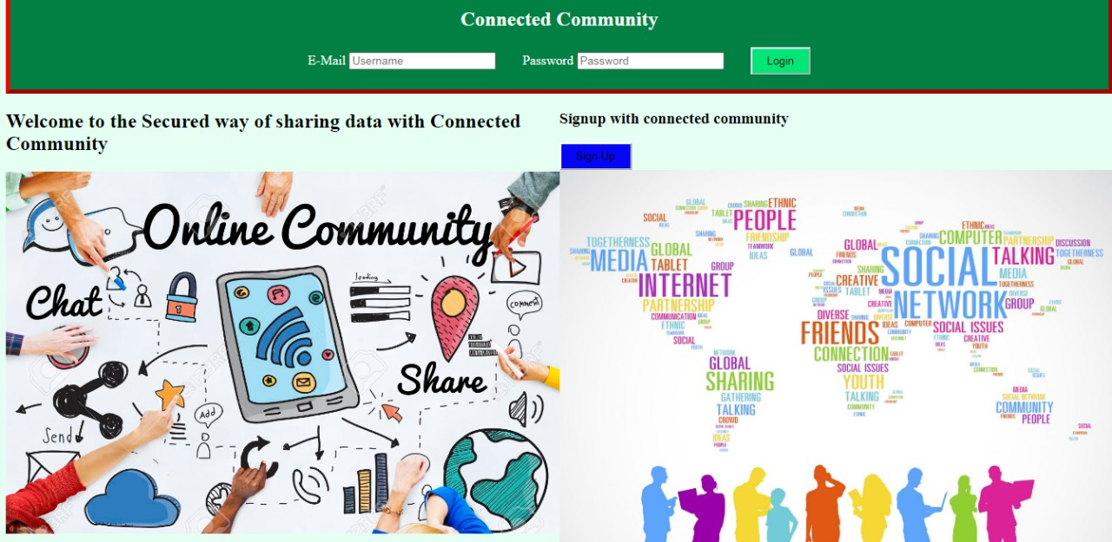

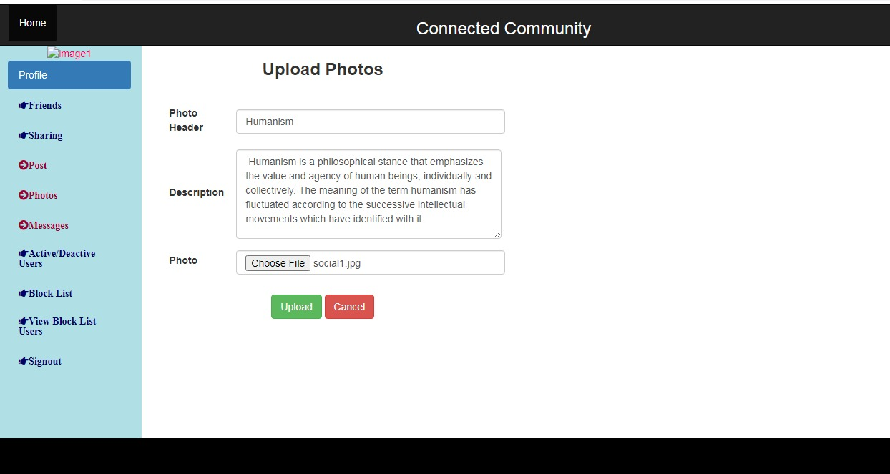

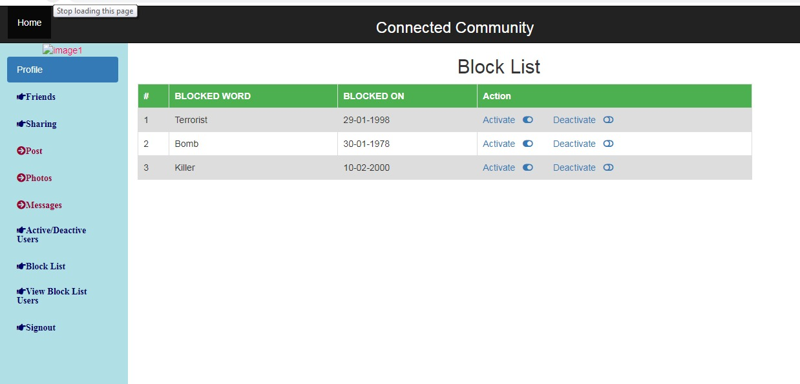

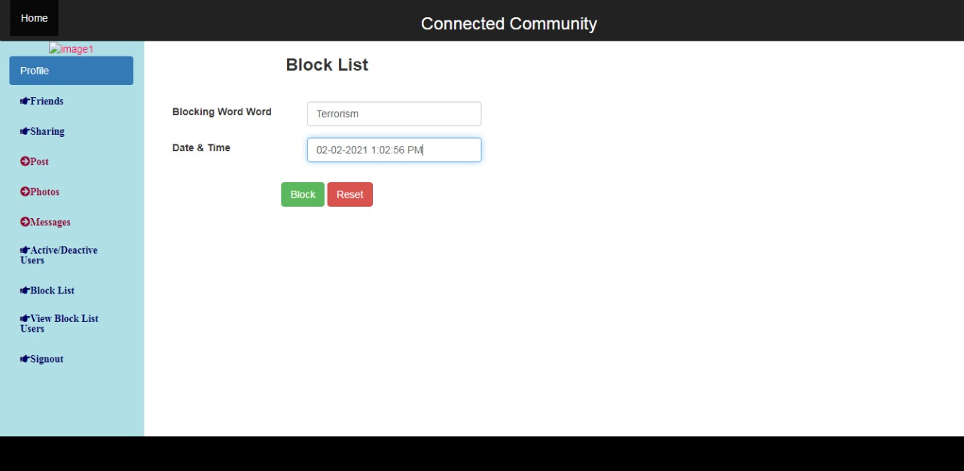

E.SAMPLE OUTPUT FORMS

